Level up load times with next-gen PCIe 4.0 NVMe performance

[Watch Video](https://www.kingston.com/en/video/play?videoId=NyTRmWbvp8EUNUcRzgD47ZFW9VXQJrX7MwrlIywaC2jADyZynaa0ezspYXZinALNfG8kxacDtkKi4lZqYG8Y0A2&start=0&autoPlay=False&chromeless=False&captionOption=No)

Kingston FURY™ Renegade SSD

* [Intro](https://www.kingston.com/en/ssd/gaming/kingston-fury-renegade-nvme-m2-ssd#product-features)
* [Key Features](https://www.kingston.com/en/ssd/gaming/kingston-fury-renegade-nvme-m2-ssd#key-feature)
* [Specifications](https://www.kingston.com/en/ssd/gaming/kingston-fury-renegade-nvme-m2-ssd#specifications)
* [Resources](https://www.kingston.com/en/ssd/gaming/kingston-fury-renegade-nvme-m2-ssd#links)
* [Datasheet](https://www.kingston.com/datasheets/sfyr_us.pdf)

[**Buy**](https://www.kingston.com/en/ssd/gaming/kingston-fury-renegade-nvme-m2-ssd#atc)

Kingston FURY Renegade PCIe 4.0 NVMe M.2 SSDFor Gamers, Enthusiasts, and High-Power Users

Kingston FURY™ Renegade PCIe 4.0 NVMe M.2 SSD provides cutting-edge performance in high capacities for gaming and hardware enthusiasts seeking extreme performance for PC builds and upgrades. By leveraging the latest Gen 4x4 NVMe controller and 3D TLC NAND, Kingston FURY Renegade SSD offers blazing speeds up to 7,300/7,000MB/s1 read/write and up to 1,000,000 IOPS1 for amazing consistency and exceptional gaming experience. From game and application loading times to streaming and capturing, give your system a boost in overall responsiveness.

With better heat management comes better stability during peak performance. The slim M.2 combined with a low profile, graphene aluminum heat spreader is optimized for intense usage in gaming laptops and desktops. The optional heatsink model delivers an additional layer of thermal dispersion so when the game heats up, your PS5™ console stays cool. Kingston FURY Renegade SSD matches the top-tier performance of the Kingston FURY Renegade memory line to produce the ultimate team that will keep you at the top of your game.

Available in capacities from 500GB–4TB2 to store an extensive library of your favorite games and media.

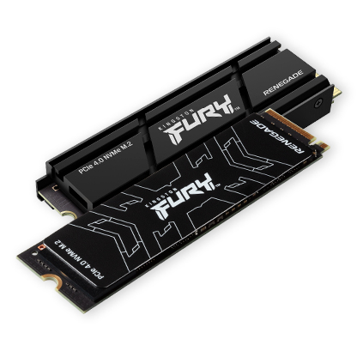

Features

* Incredible PCIe Gen 4x4 NVMe performance
* Available with heatsink or low-profile heat spreader
* Slim M.2 2280 form factor
* High capacities up to 4TB2
* PS5™ Ready

Key Features



Level up with PCIe 4.0 NVMe

Dominate with cutting-edge Gen 4x4 intense speeds up to 7,300/7,000MB/s1 read/write and up to 1,000,000 IOPS1 performance.

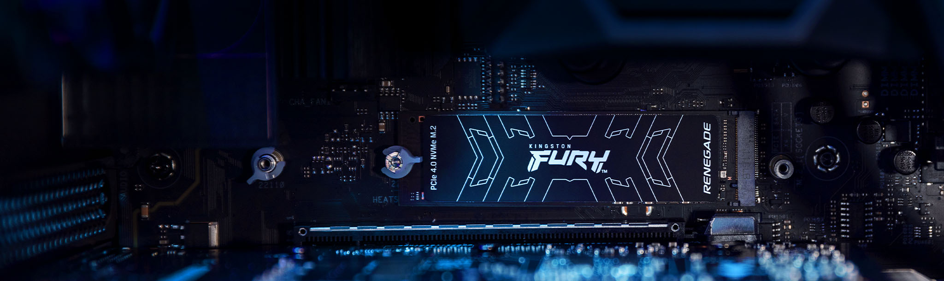

Maximize your motherboard

Powerful slim M.2 form factor to enhance your gaming rig and laptop.



More space to play

Get all the latest titles and DLC available. Performance with high capacities up to 4TB2 to store your favorite games and media.

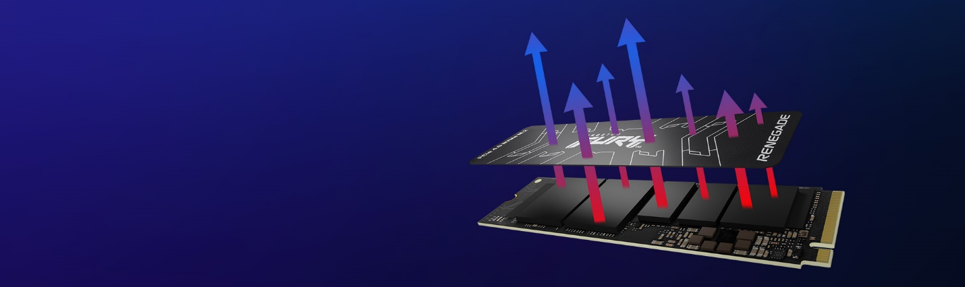

Low profile graphene aluminum heat spreader

Advanced thermal dissipation keeps your drive cool during intense usage. Brings higher performance to the tightest of spaces in gaming laptops and motherboards.



PS5™ Ready

Game-changing storage designed to maximize your play. Optional integrated aluminum heatsink model provides an additional layer of thermal dispersion to cool the drive and maintain peak performance.  
  
Works with PlayStation® 5  
  
[**Learn More**](https://www.kingston.com/solutions/gaming/ps5-ssd-nvme-m2-install)

Awards and Reviews

Great performance for the price. The most stability of these drives in the PS5.

[Read Full Review](https://nichegamer.com/reviews/kingston-fury-renegade-2tb-ssd-review/)



**Ask an SSD Expert**

Planning the right solution requires an understanding of your project's security goals. Let Kingston's experts guide you.

[**Ask an Expert**](https://www.kingston.com/en/ssd/desktop-laptop-workstations/ask-an-expert)

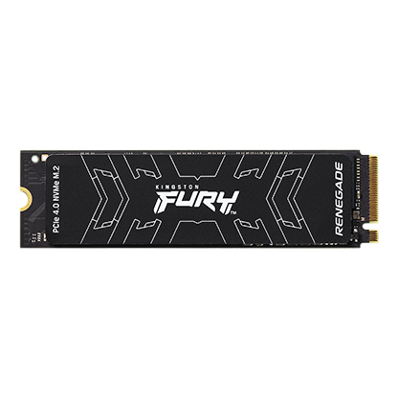

* [Kingston FURY Renegade SSD](javascript:void(0))
* [Kingston FURY Renegade SSD](javascript:void(0))
* [Kingston FURY Renegade SSD](javascript:void(0))

Capacity

 500GB

 1TB

 2TB

 4TB

Options

 Heat spreader

 Heatsink

* Part Number: SFYRS/500G
* PCIe 4.0 NVMe M.2
* 7,300MB/s Read, 3,900MB/s Write
* Includes [Acronis cloning software](https://www.kingston.com/cloning)
* Single-sided

[**Where to Buy**](https://www.kingston.com/en/wheretobuy)

Specifications

|  |  |
| --- | --- |
| Form Factor | M.2 2280 |
| Interface | PCIe 4.0 x4 NVMe |
| Capacities2 | 500GB, 1TB, 2TB, 4TB |
| Controller | Phison E18 |
| NAND | 3D TLC |
| DRAM Cache | Yes |
| Sequential Read/Write1 | 500GB – 7,300/3,900MB/s 1TB – 7,300/6,000MB/s 2TB – 7,300/7,000MB/s 4TB – 7,300/7,000MB/s |
| Random 4K Read/Write1 | 500GB – up to 450,000/900,000 IOPS 1TB – up to 900,000/1,000,000 IOPS 2TB – up to 1,000,000/1,000,000 IOPS 4TB – up to 1,000,000/1,000,000 IOPS |
| Total Bytes Written (TBW)3 | 500GB – 500TBW 1TB – 1.0PBW 2TB – 2.0PBW 4TB – 4.0PBW |
| Power Consumption | 500GB – 50mW Idle / 0.34W Avg / 2.7W (MAX) Read / 4.1W (MAX) Write 1TB – 50mW Idle / 0.33W Avg / 2.8W (MAX) Read / 6.3W (MAX) Write 2TB – 50mW Idle / 0.36W Avg / 2.8W (MAX) Read / 9.9W (MAX) Write 4TB – 50mW Idle / 0.36W Avg / 2.7W (MAX) Read / 10.2W (MAX) Write |
| Storage Temperature | -40°C~85°C |
| Operating Temperature | 0°C~70°C |
| Dimensions | Heat spreader: 80mm x 22mm x 2.21mm (500GB-1TB) 80mm x 22mm x 3.5mm (2TB-4TB) Heatsink: 80mm x 23.67mm x 10.5mm |
| Weight | Heat spreader: 500GB-1TB – 7g 2TB-4TB – 9.7g Heatsink: 500GB-1TB – 32.1g 2TB-4TB – 34.9g |
| Vibration Operating | 2.17G Peak (7-800Hz) |
| Vibration Non-operating | 20G Peak (20-1000Hz) |
| MTBF | 2,000,000 hours |
| Warranty/Support4 | Limited 5-year warranty with free technical support |